/* Assignment2, CIND119 DHC ,Mohsen Selseleh #500726502. */

# Create a database called sample

Connect mongo through cli and then run the command

**use sample;**



# Create a collection called test_data and load sample data into the collection

use sample;

db.createCollection('test_data');

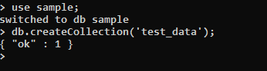

# Loading sample data

db.test_data.insert([

{ class: "NO", age: 35, menopause: "premeno", deg_malig: 3, breast: "left", breast_quad: "left_low", irradiat: "no"},

{ class: "NO", age: 42, menopause: "premeno", deg_malig: 2, breast: "right", breast_quad: "right_up", irradiat: "no"},

{ class: "NO", age: 30, menopause: "premeno", deg_malig: 2, breast: "left", breast_quad: "left_low", irradiat: "no"},

{ class: "NO", age: 61, menopause: "ge40", deg_malig: 2, breast: "right", breast_quad: "left_up", irradiat: "no"},

{ class: "NO", age: 45, menopause: "premeno", deg_malig: 2, breast: "right", breast_quad: "right_low", irradiat: "no"},

{ class: "NO", age: 64, menopause: "ge40", deg_malig: 2, breast: "left", breast_quad: "left_low", irradiat: "no"},

{ class: "NO", age: 52, menopause: "premeno", deg_malig: 2, breast: "left", breast_quad: "left_low", irradiat: "no"},

{ class: "NO", age: 67, menopause: "ge40", deg_malig: 1, breast: "left", breast_quad: "left_low", irradiat: "no"},

{ class: "YES", age: 41, menopause: "premeno", deg_malig: 2, breast: "left", breast_quad: "left_low", irradiat: "no"},

{ class: "YES", age: 43, menopause: "premeno", deg_malig: 2, breast: "right", breast_quad: "left_up", irradiat: "no"},

{ class: "YES", age: 41, menopause: "premeno", deg_malig: 3, breast: "left", breast_quad: "central", irradiat: "no"},

{ class: "YES", age: 44, menopause: "ge40", deg_malig: 2, breast: "left", breast_quad: "left_low", irradiat: "no"},

{ class: "YES", age: 61, menopause: "lt40", deg_malig: 1, breast: "left", breast_quad: "right_up", irradiat: "no"},

{ class: "YES", age: 55, menopause: "ge40", deg_malig: 3, breast: "left", breast_quad: "right_up", irradiat: "no"},

{ class: "YES", age: 44, menopause: "premeno", deg_malig: 3, breast: "left", breast_quad: "left_up", irradiat: "no"},

])

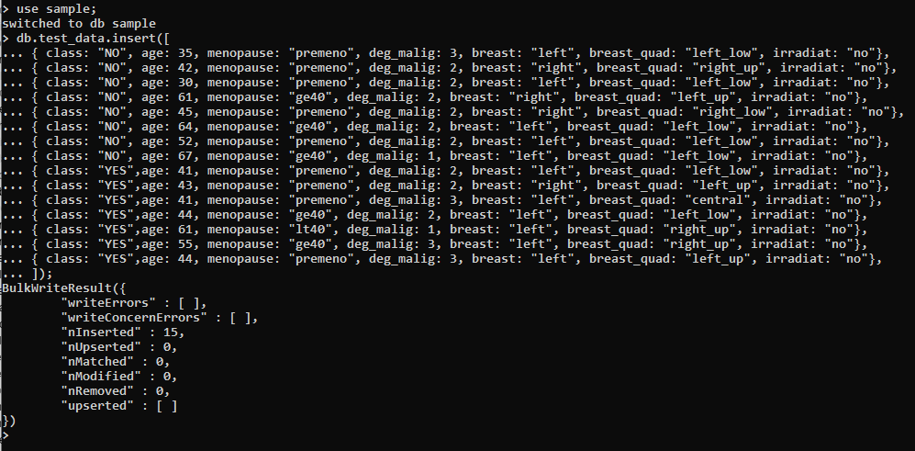

# Write MongoDB queries to select/compute data from test_data collection

## Select all the rows where menupause column has the value of “geo40”

Query:

db.test_data.find({"menopause" : "ge40"})

Output:

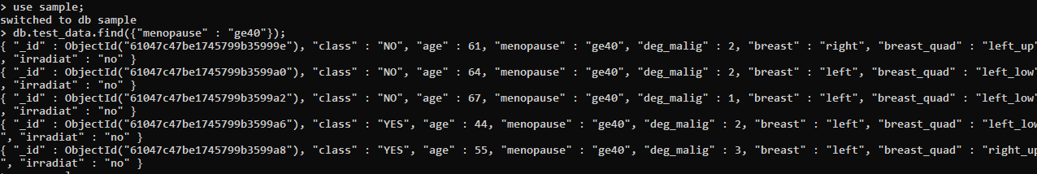

## Select all rows where age is less than 41

Query:

db.test_data.find({ "age": { $lt: 41 } })

Output:

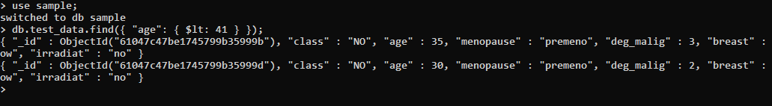

## Select all rows where age is less than 41 or the menupause column has the value of “geo40”

Query:

db.test_data.find({ $or: [{ "age": { $lt: 41 } }, { "menopause": "ge40" }] })

Output:

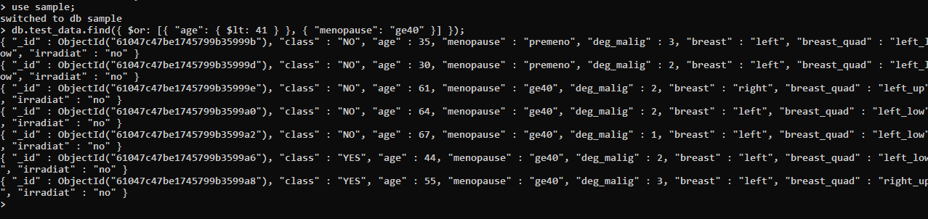

## Compute the average age across all rows

Query:

db.test_data.aggregate([

{

$group: {

_id: null,

average_age: { $avg: "$age" }

}

}

])

Output:

